**Supplementary Material 1.** Examples of matched action potential waveforms across time points. Supplemental Figures 1, 2, and 3 present examples of motor units from different participants matched across -2 weeks and 0 weeks, -2 weeks and +6 weeks, and 0 weeks and +6 weeks, respectively.

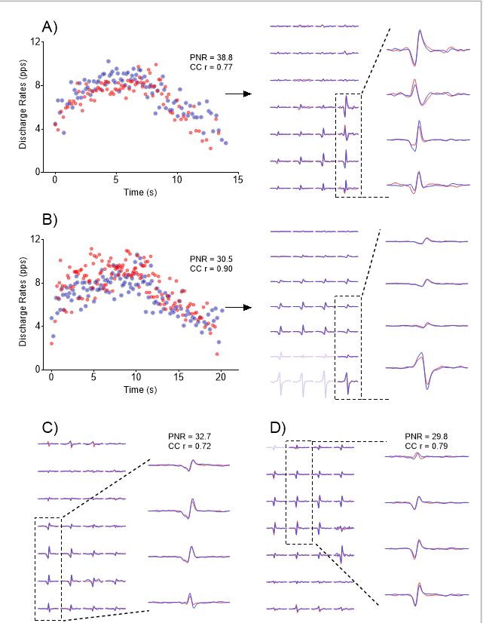

Supplemental Figure 1. Example of 4 motor units from distinct individuals tracked between -2 weeks and 0 weeks. Panels A and B present instantaneous discharge rates of 2 motor units and their respective action potentials obtained from bipolar high-density EMG signals. Panels C and D present the action potentials of another 2 motor units. The columns and rows represent channels from the HD-EMG 32-channel electrode matrices. Spike-triggered averaging was used to extract the motor unit action potentials from their discharge events. Instantaneous firing frequencies and motor unit action potentials at -2 weeks (red) and 0 weeks (blue) training are overlapped. PNR, pulse-to-noise ration; CC r, cross-correlation coefficient r.

Supplemental Figure 2. Example of 4 motor units from distinct individuals tracked between -2 weeks and +6 weeks. Panels A and B present instantaneous discharge rates of 2 motor units and their respective action potentials obtained from bipolar high-density EMG signals. Panels C and D present the action potentials of another 2 motor units. The columns and rows represent channels from the HD-EMG 32-channel electrode matrices. Spike-triggered averaging was used to extract the motor unit action potentials from their discharge events. Instantaneous firing frequencies and motor unit action potentials before (red) and after (blue) training are overlapped. PNR, pulse-to-noise ration; CC r, cross-correlation coefficient r.

Supplemental Figure 3. Example of 4 motor units from distinct individuals tracked between 0 weeks and +6 weeks. Panels A and B present instantaneous discharge rates of 2 motor units and their respective action potentials obtained from bipolar high-density EMG signals. Panels C and D present the action potentials of another 2 motor units. The columns and rows represent channels from the HD-EMG 32-channel electrode matrices. Spike-triggered averaging was used to extract the motor unit action potentials from their discharge events. Instantaneous firing frequencies and motor unit action potentials before (red) and after (blue) training are overlapped. PNR, pulse-to-noise ration; CC r, cross-correlation coefficient r.